|  |  |
| --- | --- |
|  | **Title in Spanish, left-aligned, Arial 16, single-spaced (1)**  Title in English, left-aligned, Arial 14, single-spaced (1)  Title in Portuguese, left-aligned, Arial 14, single-spaced (1) |
|  | |
|  | First name and two surnames  Institutional affiliation  City, Country  E-mail address in light blue  ORCID: https: Complete the identifier  First name and two surnames  Institutional affiliation  City, Country  E-mail address in light blue  ORCID: https: Complete the identifier |
|  |  |
| Recibido – Received – Recebido: To be completed by the Journal  Corregido – Reviewed– Revisado: To be completed by the Journal  Aceptado – Accepted – Aprovado: To be completed by the Journal | |
| DOI: TO BE COMPLETED BY THE JOURNAL  URL: TO BE COMPLETED BY THE JOURNAL | |
|  | |

|  |
| --- |
| **Resumen**: Incluya un resumen informativo de entre 200 y 250 palabras, donde exponga de qué se trata el trato el ensayo, la temática en estudio, los análisis realizados y la principal conclusión. |
| *Palabras claves*: Presente entre cinco y siete palabras clave, utilizando el tesauro de la UNESCO, con sus respectivas traducciones al inglés o al español, según corresponda. Puede consultar el Tesauro de la UNESCO en: <http://vocabularies.unesco.org/browser/thesaurus/es/> |
| **Abstract**: Include an informative summary of 200-250 words explaining what the essay is about, the topic under study, the analyses performed, and the main conclusion. |
| *Keywords*: Include between five and seven key words, using the UNESCO Thesaurus, with their respective translations in English or Spanish, as appropriate. You can consult the UNESCO Thesaurus at: http://vocabularies.unesco.org/browser/thesaurus/es/ |
| **Resumo**: Inclua um resumo informativo de 200 a 250 palavras, onde você explique do que se trata o ensaio, o assunto em estudo, as análises realizadas e a principal conclusão |
| *Palavras-chave*: Apresentar entre cinco e sete palavras-chave, usando o thesaurus da UNESCO, com suas respectivas traduções para o inglês ou espanhol, conforme o caso. Você pode consultar o Thesaurus da UNESCO em: http://vocabularies.unesco.org/browser/thesaurus/es/ |

**NOTE: The font should be Arial 10, black, justified and single spaced (1).**

**INTRODUCTION**

It must include the contextualization and significance of the essay. It is suggested that the last paragraph of the introduction be used to express the general objective of the essay. Do not include subtitles in this section.

**NOTE: The font should be Arial 12, black, justified alignment and 1.15 line spacing.**

As for the tables, we will use APA fourth edition in Spanish:

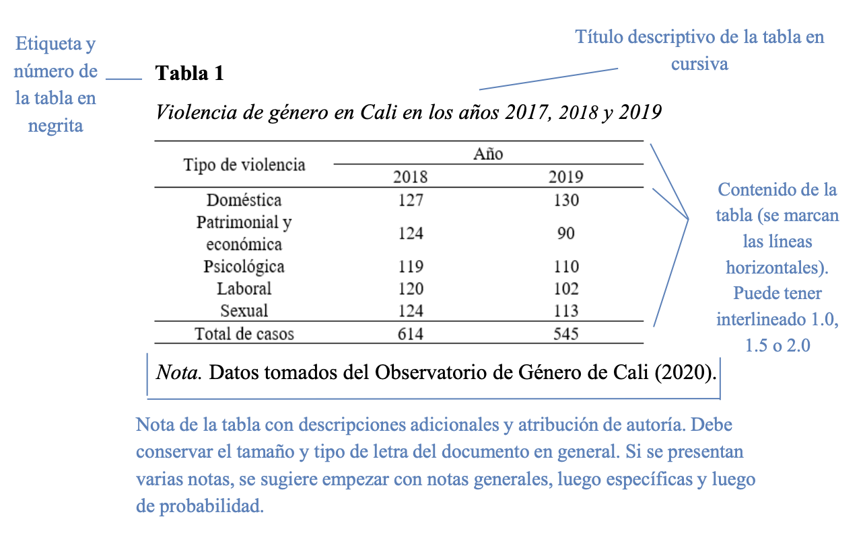

**The font used for the tables is Arial 10 for the table numbering and the title; the font used for the body of the table is Arial 8, single spaced (1).**

Figures should be presented in APA format, fourth edition, in Spanish:

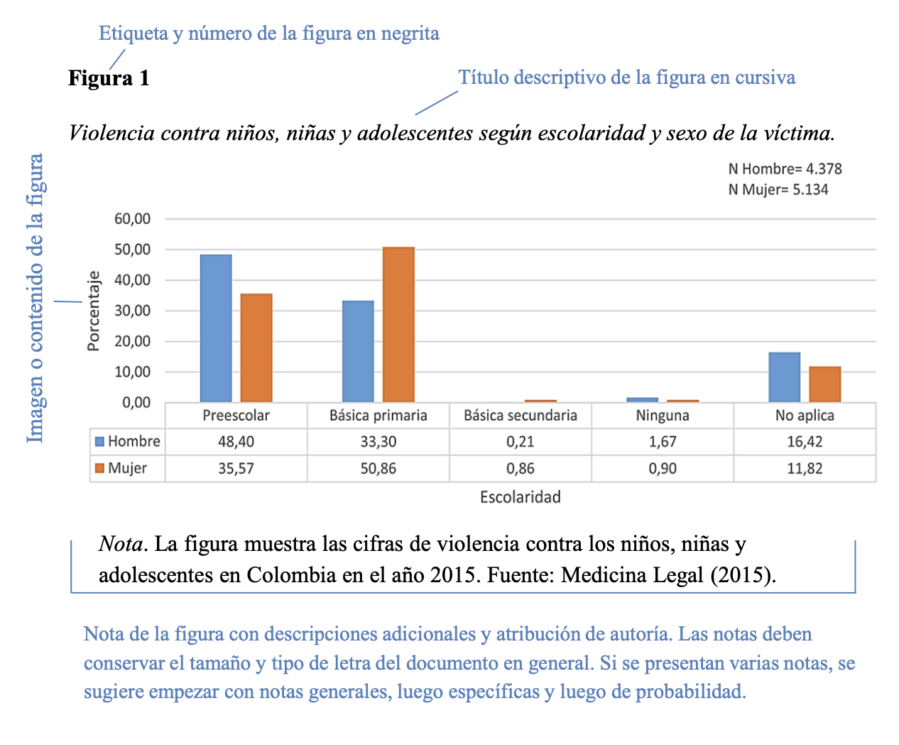

**The title and numbering of tables should be in Arial 10; the body of the table should be in Arial 9.**

**If figures include graphics, use the following color palette:**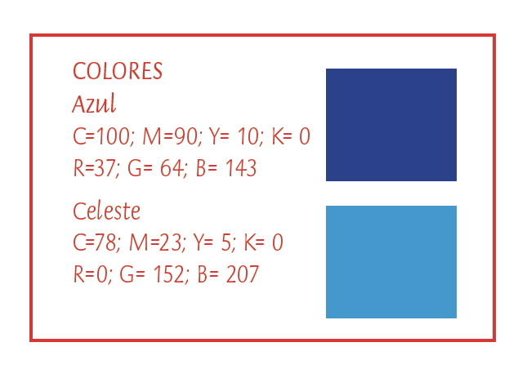

**If it is necessary to use additional colors, the choice of these colors is left to the author, while using similar colors.**

**DEVELOPMENT OF THE TOPIC**

The essay should include the topic statement, arguments for discussion, and reflections on the topic. This section should contain all the explanations needed to fulfill the purpose of the essay. To do this, use long argumentative paragraphs (each focusing on one idea within the essay), transitional paragraphs (between argumentative paragraphs) to connect or recapitulate ideas, linguistic connectors, and concrete examples. It must include bibliographic citations.

**NOTE: Font must be Arial 12, black, justified alignment and 1.15 line spacing.**

**SYNTHESIS AND FINAL REFLECTIONS**

This section summarizes (or recapitulates) the ideas discussed in the arguments and introduction. The conclusion formula is the opposite of the introduction: it begins with a brief summary of the paper and ends with a powerful sentence to draw the reader's attention to the main point of the paper. This last sentence should reflect the focus of the essay.

**NOTE: Font must be Arial 12, black, justified alignment and 1.15 line spacing.**

**REFERENCES**

Include the bibliographical references of your work according to the standards of the APA (*American Psychological Association*), seventh edition in English or fourth edition in Spanish. Include only those works cited in the body of the paper.

**NOTE: Font must be Arial 9, black, justified alignment, single spacing (1).**

**GENERAL ASPECTS TO BE CONSIDERED**

* The document must be original, i.e. it must be the first time that it is presented to the scientific community and it must not be under review at the same time by other publishing houses.
* Papers should not exceed 25 letter-sized pages, including the main text and any figures or tables. The cover page and abstract are not included in the 25 pages.
* It must be written according to the format specified by the journal.
* It may be written by one or more authors.
* It must use language specific to the field of education.
* Footnotes are not allowed.
* The affidavit of authorship must be signed and submitted with the paper.

It must be submitted through the UNED journal management system (https://revistas.uned.ac.cr/index.php/innovaciones/about/submissions)