Title in Spanish, left aligned, size 16, Arial font, single-spaced (1)

Title in English, left aligned, size 14, Arial font, single-spaced (1)

Title in Portuguese, left aligned, size 14, Arial font, single spaced (1)

First name and two last names
Institutional affiliation
City, Country
E-mail address in light blue
ORCID: https: Fill in the identifier.

Name and two last names
Institutional affiliation
City, Country
Email address in light blue
ORCID: https: Fill in the identifier.

Received – Recibido – Recebido: Completed by the Journal
Revised – Corregido – Revisado: Completed by the Journal
Accepted – Aceptado – Aprovado: Completed by the Journal
DOI: COMPLETED BY THE JOURNAL
URL: COMPLETED BY THE JOURNAL

Abstract: It must have an informative abstract of 200 to 250 words where the main ideas discussed in the manuscript are presented in accordance with the objective of the review, the analyses performed and the main conclusion.

Keywords: Submit between five and seven key words, using the UNESCO thesaurus, with their respective translations into English or Spanish, as suitable. You can consult the UNESCO Thesaurus at: http://vocabularies.unesco.org/browser/thesaurus/es/

Resumen: Debe tener un resumen informativo de entre 200 a 250 palabras donde exponga las principales ideas que se tratan en el manuscrito en concordancia con el objetivo de la revisión, los análisis realizados y la principal conclusión

Palabras claves: Presente entre cinco y siete palabras clave, utilizando el tesauro de la UNESCO, con sus respectivas traducciones al inglés o al español, según corresponda. Puede consultar el Tesauro de la UNESCO en: http://vocabularies.unesco.org/browser/thesaurus/es/

Resumo: Deve ter um resumo informativo de 200 a 250 palavras onde exponha as principais ideias que são tratadas no manuscrito de acordo com o objetivo da revisão, as análises realizadas e a conclusão principal.

Palavras-chave: Apresentar entre cinco e sete palavras-chave, usando o thesaurus da UNESCO, com suas respectivas traduções para o inglês ou espanhol, conforme o caso. Você pode consultar o Thesaurus da UNESCO em: http://vocabularies.unesco.org/browser/thesaurus/es/

NOTE: The font size is 10 points, with Arial font, black color, justified alignment and
single spacing (1).

INTRODUCTION

This section should include:

- Contextualization of the topic to be presented.
- Explain the original concern that gives rise to the review.
- Present a brief background.
- The last paragraph of the introduction expresses the general and/or specific objective.

There should be no subheadings within this section.

NOTE: Font size is 12-point, font Arial, color black, alignment is justified and line spacing is 1.15.

As for the tables, they are presented with APA fourth edition in Spanish:

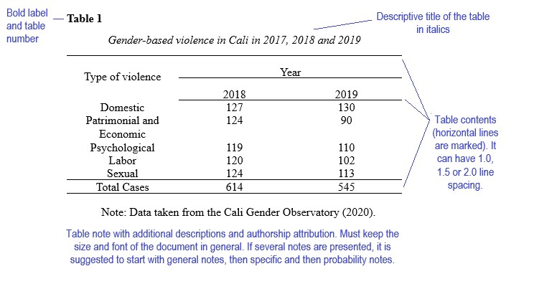

The tables use Arial font with a size of 10 points for the numbering of the table and the title, for the body of the table the font size is 9 points, single spacing (1).

As for the figures, they are presented with APA fourth edition in Spanish:

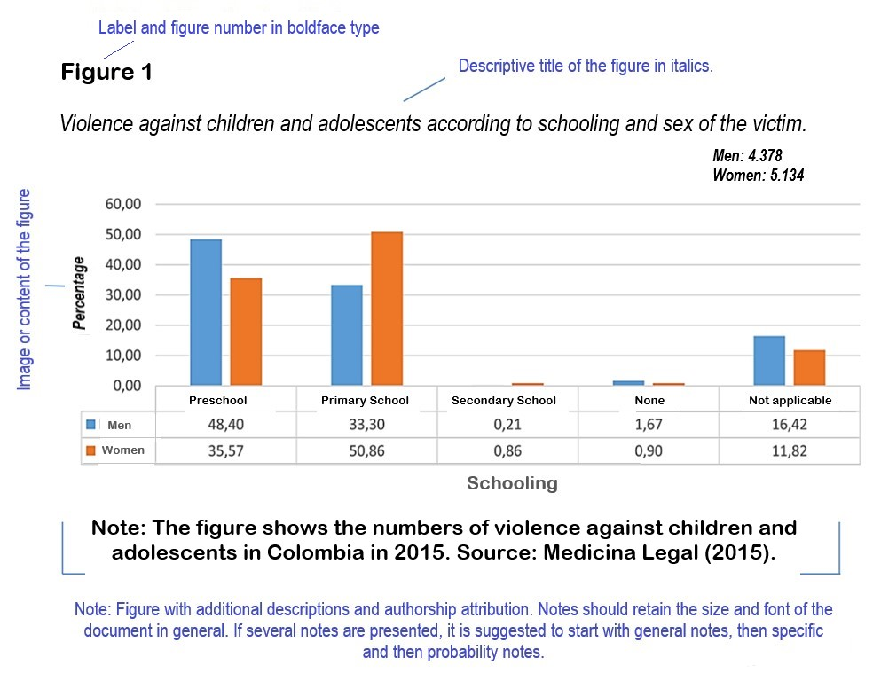

In the figures, Arial font is used with a size of 10 points for the numbering of the table and the title; for the body of the table the font size is 9 points.

When figures use graphics, the following color palette should be used:

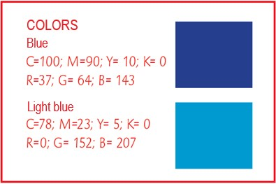

If more colors are required, it is the author's free choice, keeping similar colors.

LITERATURE REVIEW

This section should include:

- a brief background.
- theoretical description according to the review of sources.

There should be no subheadings within this section.

NOTE: Font size is 12-point, font Arial, color black, alignment is justified and line spacing is 1.15.

DISCUSSION OF RESULTS

This section requires depth in the reflection of the review, it must show the coherence between the ideas presented, the theoretical positions and the reflection or position of the author on the topic resulting from the review.

NOTE: Font size is 12-point, font Arial, color black, alignment is justified and line spacing is 1.15.

SYNTHESIS AND FINAL THOUGHTS

It should restate the most important ideas presented in the bibliographic review, the conclusions of the main topic ideas and the contribution that the review provides to the academic discipline and/or professional development should be presented. In addition, it is convenient to provide information that allows capturing information about gaps or new aspects in the field of Educational Sciences.

NOTE: Font size is 12-point, font Arial, color black, alignment is justified and line spacing is 1.15.

REFERENCES

List the bibliographical references of your work, according to APA (American Psychological Association) standards, Seventh edition in English or Fourth edition in Spanish. Include only the works that have been cited in the body of the article.

NOTE: Font size is 9-point, font Arial, color black, alignment is justified, single spacing (1).

GENERAL ASPECTS TO CONSIDER

- The document must be original, meaning, it is presented for the first time to the scientific community and must not be subject to review by other publishing entities at the same time.

- Papers should have a maximum of 25 letter-size pages, including the main text and any figures or tables that may be added, not including a cover page and abstract.

- It must follow the template format that the Journal has established.

- It can be written by one person or several.

- It must contain technical language related to the field of educational sciences.

- Explanatory footnotes are not allowed.

- The affidavit of authorship must be signed and submitted with the manuscript.

- It must be submitted through UNED’s journal management system (https://revistas.uned.ac.cr/index.php/innovaciones/about/submissions ).

