Title in Spanish, left aligned, size 16, Arial font, single-spaced (1)

Title in English, left aligned, size 14, Arial font, single-spaced (1)

Title in Portuguese, left aligned, size 14, Arial font, single spaced (1)

First name and two last names
Institutional affiliation
City, Country
E-mail address in light blue
ORCID: https: Fill in the identifier.

Name and two last names
Institutional affiliation
City, Country
Email address in light blue
ORCID: https: Fill in the identifier.

Received – Recibido – Recebido: Completed by the Journal
Revised – Corregido – Revisado: Completed by the Journal
Accepted – Aceptado – Aprovado: Completed by the Journal
DOI: COMPLETED BY THE JOURNAL
URL: COMPLETED BY THE JOURNAL

Abstract: Include an informative abstract between 200 and 250 words, stating what the article is about, the study population, the methodology used, the main result and the main conclusion.

Keywords: Submit five to seven keywords, using the UNESCO Thesaurus, with their respective translations into English or Spanish, as suitable. The UNESCO Thesaurus can be consulted at: http://vocabularies.unesco.org/browser/thesaurus/es/

Resumen: Incluya un resumen informativo de entre 200 y 250 palabras, donde exponga de qué se trata el artículo, cuál es la población de estudio, la metodología utilizada, el principal resultado y la principal conclusión.

Palabras claves: Presente entre cinco y siete palabras clave, utilizando el tesauro de la UNESCO, con sus respectivas traducciones al inglés o al español, según corresponda. Puede consultar el Tesauro de la UNESCO en: http://vocabularies.unesco.org/browser/thesaurus/es/

Resumo: Inclua um resumo informativo de 200 a 250 palavras, onde você explique do que se trata o artigo, qual é a população do estudo, a metodologia utilizada, o resultado principal e a conclusão principal.

Palavras-chave: Apresentar entre cinco e sete palavras-chave, usando o thesaurus da UNESCO, com suas respectivas traduções para o inglês ou espanhol, conforme o caso. Você pode consultar o Thesaurus da UNESCO em: http://vocabularies.unesco.org/browser/thesaurus/es/

NOTE: The font size is 10 points, with Arial font, black color, justified alignment and
single spacing (1).

INTRODUCTION

The first section of the article should be the "Introduction" and it would include:
- the justification,
- the background,
- the main theoretical references,
- the research problem
- the objectives, the latter are presented in the last paragraph.

There should be no subheadings within this section.

NOTE: Font size is 12-point, font Arial, color black, alignment is justified and line spacing is 1.15.

As for the tables, they are presented with APA fourth edition in Spanish:

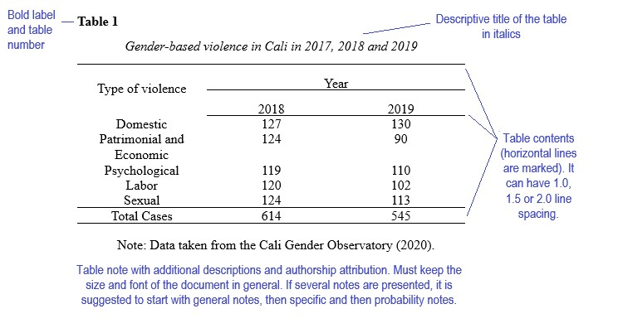

The tables use Arial font with a size of 10 points for the numbering of the table and the title, for the body (content) of the table the font size is 9 points, single spacing (1).

As for the figures, they are presented with APA fourth edition in Spanish:
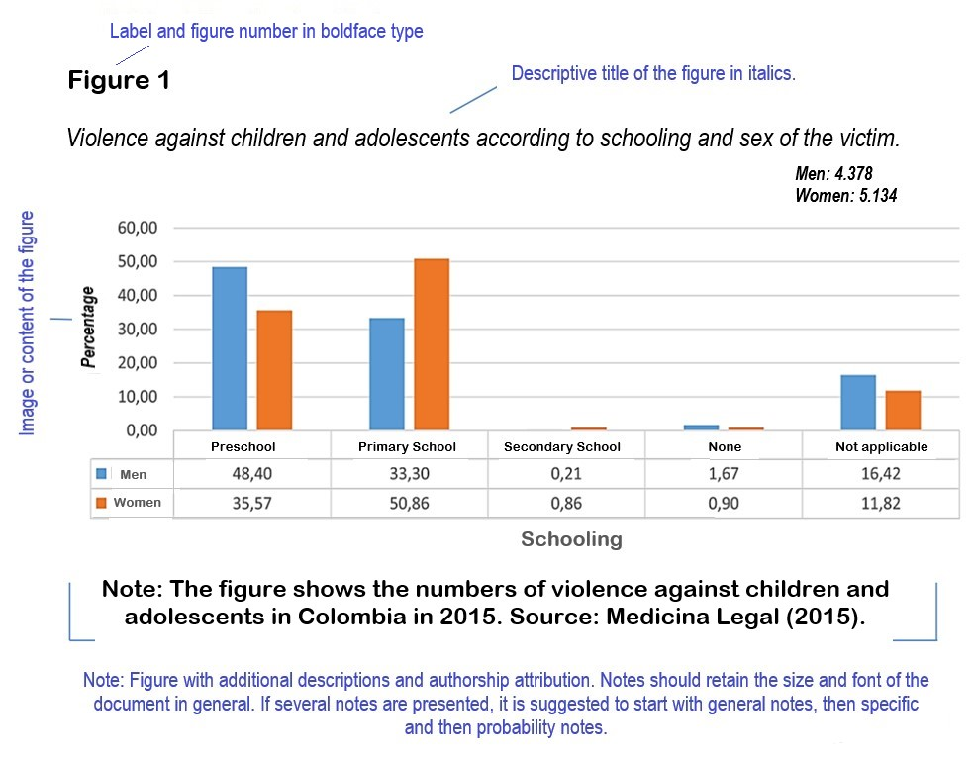
In the figures, Arial font is used with a size of 10 points for the numbering of the table and the title; for the body of the table the font size is 9 points.

When figures use graphics, the following color palette should be used:

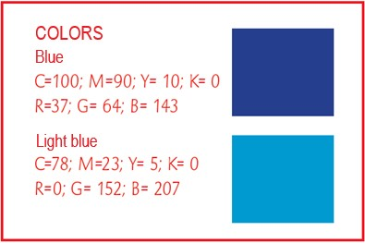

If more colors are required, it is the author's free choice, keeping similar colors.

MATERIALS AND METHODS

The second section corresponds to "Materials and methods", which should include:
- the research focus and its design.
- the population you worked with and the sample, as well as the way in which you have made your selection,
- the techniques and instruments used (validity and reliability criteria),
- the context,
- indicate how the analysis of the information was carried out.

There should be no subheadings in this section.

NOTE: Font size is 12-point, font Arial, color black, alignment is justified and line spacing is 1.15.

DISCUSION OF RESULTS

Include in this section tables, figures or charts that clearly express the results of the study. These should fulfill two functions: to relate these results to the specific objectives proposed and to present evidence. The first paragraph of this text should be used to summarize in a concise, clear, and direct sentence the main finding of the study. This section should be written using verbs in the past tense.

NOTE: Font size is 12-point, font Arial, color black, alignment is justified and line spacing is 1.15.

CONCLUSIONS

According to the previous section, write the conclusions where the findings of your work are consolidated. These conclusions should be based on the specific objectives. Try as much as possible to give a coherent explanation of what you have found. Include any recommendations you think are appropriate. And avoid drawing conclusions that are not supported by the results.

NOTE: Font size is 12-point, font Arial, color black, alignment is justified and line spacing is 1.15.

REFERENCES

List the bibliographical references of your work, according to APA (American Psychological Association) standards, Seventh edition in English or Fourth edition in Spanish. Include only the works that have been cited in the body of the article.

NOTE: Font size is 9-point, font Arial, color black, alignment is justified, single spacing (1).

GENERAL ASPECTS TO CONSIDER

- The document must be original, meaning, it is presented for the first time to the scientific community and must not be subject to review by other publishing entities at the same time.

- Papers should have a maximum of 25 letter-size pages, including the main text and any figures or tables that may be added, not including a cover page and abstract.

- It must follow the template format that the Journal has established.

- It can be written by one person or several.

- It must contain technical language related to the field of educational sciences.

- Explanatory footnotes are not allowed.

- The affidavit of authorship must be signed and submitted with the manuscript.

- It must be submitted through UNED’s journal management system (https://revistas.uned.ac.cr/index.php/innovaciones/about/submissions ).

