Title in Spanish, left aligned, size 16, Arial font, single-spaced (1)

Title in English, left aligned, size 14, Arial font, single-spaced (1)

Title in Portuguese, left aligned, size 14, Arial font, single spaced (1)

First name and two last names
Institutional affiliation
City, Country
E-mail address in light blue
ORCID: https: Fill in the identifier.

Name and two last names
Institutional affiliation
City, Country
Email address in light blue
ORCID: https: Fill in the identifier.

Received – Recibido – Recebido: Completed by the Journal
Revised – Corregido – Revisado: Completed by the Journal
Accepted – Aceptado – Aprovado: Completed by the Journal
DOI: COMPLETED BY THE JOURNAL
URL: COMPLETED BY THE JOURNAL

Abstract: Include an informative abstract between 200 and 250 words, stating what the article is about, the study population, the methodology used, the main result and the main conclusion.

Keywords: Submit five to seven keywords, using the UNESCO Thesaurus, with their respective translations into English or Spanish, as suitable. The UNESCO Thesaurus can be consulted at: http://vocabularies.unesco.org/browser/thesaurus/es/

Resumen: Incluya un resumen informativo de entre 200 y 250 palabras, donde exponga de qué se trata el artículo, cuál es la población de estudio, la metodología utilizada, el principal resultado y la principal conclusión.

Palabras claves: Presente entre cinco y siete palabras clave, utilizando el tesauro de la UNESCO, con sus respectivas traducciones al inglés o al español, según corresponda. Puede consultar el Tesauro de la UNESCO en: http://vocabularies.unesco.org/browser/thesaurus/es/

Resumo: Inclua um resumo informativo de 200 a 250 palavras, onde você explique do que se trata o artigo, qual é a população do estudo, a metodologia utilizada, o resultado principal e a conclusão principal.

Palavras-chave: Apresentar entre cinco e sete palavras-chave, usando o thesaurus da UNESCO, com suas respectivas traduções para o inglês ou espanhol, conforme o caso. Você pode consultar o Thesaurus da UNESCO em: http://vocabularies.unesco.org/browser/thesaurus/es/

NOTE: The font size is 10 points, with Arial font, black color, justified alignment and
single spacing (1).

INTRODUCTION

This section should include:

- The topic contextualization in order to understand the basis of the experience explains the problem that was intended to be addressed in the experience developed.
- It specifies the theoretical and epistemological position on which the systematization of the experience is based.
- It presents a brief background.
- The last paragraph of the introduction expresses the general and/or specific objective of the document.

There should be no subheadings within this section.

NOTE: Font size is 12-point, font Arial, color black, alignment is justified and line spacing is 1.15.

As for the tables, they are presented with APA fourth edition in Spanish:

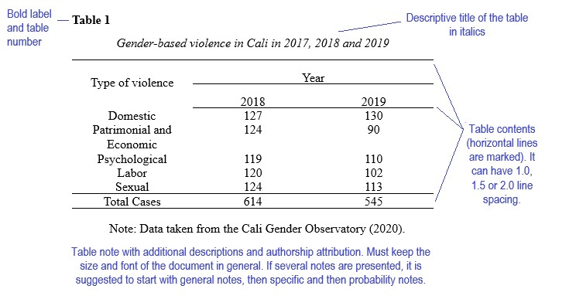

The tables use Arial font with a size of 10 points for the numbering of the table and the title, for the body of the table the font size is 9 points, single spacing (1).

As for the figures, they are presented with APA fourth edition in Spanish:

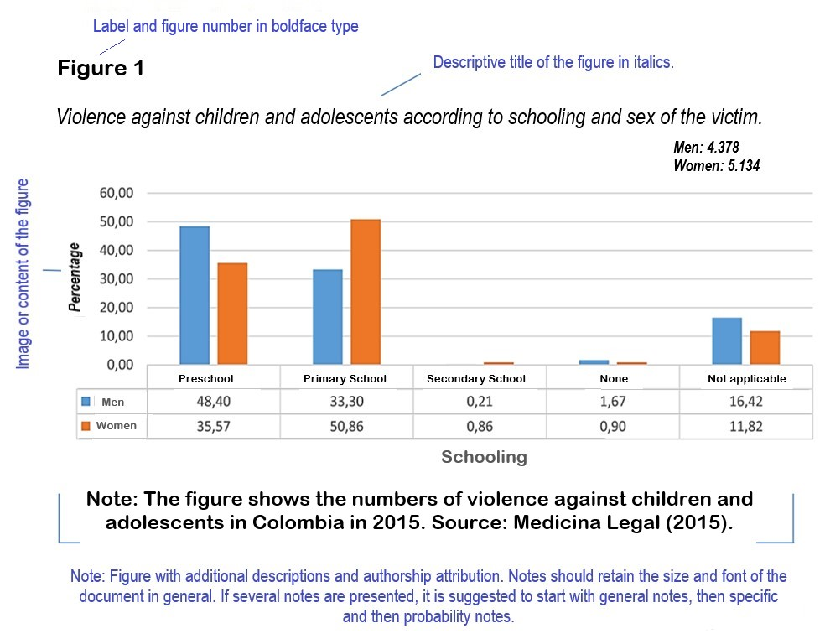

In the figures, Arial font is used with a size of 10 points for the numbering of the table and the title; for the body of the table the font size is 9 points.

When figures use graphics, the following color palette should be used:

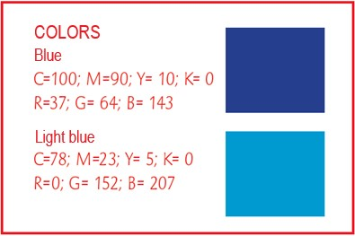

If more colors are required, it is the author's free choice, keeping similar colors.

DEVELOPMENT OF THE EXPERIENCE

The second section should include:

- A contextualization of the experience to understand the work path achieved.
- Detail the methodology used for the collection and analysis of the information related to the experience. Information should be provided on the method, instruments, selection criteria, participants, among other relevant data to understand the experience.
- Reflect on the experience, maintaining coherence between the ideas presented, the theoretical positions and the reflection or position of the author.
- The results of the experience in consistency with the proposed objectives, the contrast with the theory and the methodological coherence.
- It is convenient to provide information to understand that the experience deals with new or underdeveloped topics in the field of Educational Sciences.

NOTE: Font size is 12-point, font Arial, color black, alignment is justified and line spacing is 1.15.

SYNTHESIS AND FINAL THOUGHTS

It should restate the most important ideas presented in the document. It should offer clearly constructed conclusions and should make explicit the contribution that systematization provides to academic discipline and/or professional development. In addition, it should provide input for the development of new research or innovative experiences in the field of education.

NOTE: Font size is 12-point, font Arial, color black, alignment is justified and line spacing is 1.15.

REFERENCES

List the bibliographical references of your work, according to APA (American Psychological Association) standards, Seventh edition in English or Fourth edition in Spanish. Include only the works that have been cited in the body of the article.

NOTE: Font size is 9-point, font Arial, color black, alignment is justified, single spacing (1).

GENERAL ASPECTS TO CONSIDER

- The document must be original, meaning, it is presented for the first time to the scientific community and must not be subject to review by other publishing entities at the same time.

- Papers should have a maximum of 25 letter-size pages, including the main text and any figures or tables that may be added, not including a cover page and abstract.

- It must follow the template format that the Journal has established.

- It can be written by one person or several.

- It must contain technical language related to the field of educational sciences.

- Explanatory footnotes are not allowed.

- The affidavit of authorship must be signed and submitted with the manuscript.

- It must be submitted through UNED’s journal management system (https://revistas.uned.ac.cr/index.php/innovaciones/about/submissions ).

