For a better result, please use of this template using the functions "Copy" and "Paste plain text" in each section.
SPECIAL ARTICLE

Title of the article (Calibri 14pt, centered, bold, except scientific names. For studies on plants include Family, for studies on animals (Order: Family). Must be concise, easy to understand, and strictly related to what is presented in the article (15 words maximum).

Author complete name¹, Author complete name², Author complete name³ & Author complete name⁴

Calibri 10pt, left aligned, bold. The name of the authors is written in full, last name after the name or middle name.

Affiliations (Calibri 9pt)
Addresses are numbered, finishing with a “;” followed by the email address (do not include the word "email") and the ORCID identification number, separated by a comma. When two or more authors share the same affiliation, separate the next email address with a comma.
Example:
1. Instituto Nacional de Salud, Grupo de Microscopía y Análisis de Imágenes, Av. Calle 26 Nº 51-60 Bogotá, Colombia; lsarmiento@ins.gov.co, https://orcid.org/0000-0002-4018-775X
2. Universidad Estatal a Distancia, Vicerrectoría de Investigación, Laboratorio de Ecología Urbana, 2050 Sabanilla, San José, Costa Rica; cseas@uned.ac.cr, https://orcid.org/0000-0002-4018-775X
3. University of Georgia, Costa Rica Campus. Apartado 108-5655, Monteverde, Costa Rica; fabricio@uga.edu, https://orcid.org/0000-0002-4018-775X
4. Council on International Educational Exchange, Sustainability Center Monteverde, Costa Rica; kmasters@ciee.org, https://orcid.org/0000-0002-4018-775X

Please do not write here Received XX-XX-XXXX Corrected XX-XX-XXXX Accepted XX-XX-XXXX
DOI:

ABSTRACT. Calibri, 9pt, justified. The text will include the main objectives of the research, scope, methodology employed, main results and conclusions. The abstract must be clear, coherent and concise, for which it is suggested to review and verify data, syntax, spelling, do not include equations, figures, tables, or bibliographic references. It must accurately reflect the content of the article. It must be written in first person. It should be only one paragraph of 300-500 words  Example:  ABSTRACT. Introduction: Some introduced plant species changed Costa Rican history since the sixteenth century. Of those, many have become our most socio-economically and environmentally influential crop species, others became naturalized and some turned invasive, and in recent years new species are still being intentionally or unintentionally introduced. Objective: The aim of this work was to register as many as possible of the known alien species of seed plants in Costa Rica, to establish their origin, adding natural history data, and uses in this country. Results: There are 144 families, 623 genera and ca. 982 species according to this study. The 29 most diverse families (each one with 10 or more species) comprehend 60% of genera and 62% of alien plant species in this country, but these families represent only 20% of the total number of families with alien genera and species in Costa Rica, whereas 57% of all such families have fewer than 5 introduced species each. Fabaceae in a broad sense not only possesses the greatest numbers of genera (46) and species (70), but also it almost duplicates the figures of the second family Poaceae (with 27 and 39, respectively), meanwhile this last family has the same number of alien species as the third one Lamiaceae. Discussion: Six of the most diverse families of the Costa Rican native flora (Asteraceae, Euphorbiaceae, Fabaceae, Orchidaceae, Poaceae, and Rubiaceae) are at the same time groups with many alien, cultivated and naturalized species in this country, but the most diverse native family, Orchidaceae is number 27 in part due to the troublesome quantification of hybrids.  Keywords: Calibri, 9pt, left aligned, lowercase and separated by commas, must include 5-7 words that describe the topic and that are not in the title, nor in the abstract. | RESUMEN. Calibri, 9pt, justified. Include the title of the article in Spanish in between quotation marks “”. Follow the same structure, format and length as the abstract. It helps to identify the main topics or aspects of the article and is important for indexing in bibliographic databases.  Ejemplo:  RESUMEN. “Origen, historia natural y usos de las plantas introducidas en Costa Rica”. Introducción: Algunas especies de plantas introducidas cambiaron la historia de Costa Rica desde el siglo XVI. Muchas se convirtieron en los cultivos socioeconómica y ambientalmente más impactantes de este país; otras se naturalizaron, algunas se volvieron invasoras y en años recientes nuevas especies todavía siguen llegando como inmigrantes, o son introducidas intencionalmente. Objetivo: El objetivo de este trabajo fue registrar el mayor número posible de plantas seminíferas alóctonas de Costa Rica, establecer su origen y aportar datos sobre historia natural y usos en este país. Resultados: Se trata de 144 familias, 623 géneros y ca. 982 especies. Las 29 familias con mayores números de especies alóctonas (cada una con 10 o más especies) abarcan el 60% de los géneros y 62% de tales especies en este país, pero estas familias representan solamente el 20% del total de familias con géneros y especies introducidos en Costa Rica, mientras que 57% de todas esas familias poseen cada una menos de 5 especies introducidas. Fabaceae en sentido amplio no solamente posee los mayores números de géneros (46) y especies (70), sino que, además, casi duplica las cifras de la segunda familia, Poaceae (con 27 y 39, respectivamente), mientras que esta familia registra el mismo número de especies de la tercera, Lamiaceae. Discusión: Seis de las familias más diversas de la flora nativa de Costa Rica (Asteraceae, Euphorbiaceae, Fabaceae, Orchidaceae, Poaceae y Rubiaceae) también son grupos con abundantes especies alóctonas cultivadas y naturalizadas en este país, pero Orchidaceae, la más diversa de las familias nativas, aquí es la 27, en parte debido a la dificultad de cuantificar híbridos.  Palabras clave: Calibri, 9pt, left aligned, lowercase and separated by commas, must include 5-7 words in Spanish that describe the topic and that are not in the title, nor in the abstract.

The content of the special articles uses Calibri, 11, justified, each paragraph indented in the first line. This type of publication does not have a word limit, however it is important to communicate with us (email: researchjournal@uned.ac.cr) to get a quote for the costs of publication. Authors are requested to cover the costs associated with the publication of special articles.
We recommend following the sequence: INTRODUCTION (which closes with the objective), MATERIALS AND METHODS, RESULTS and DISCUSSION. These subtitles are written in uppercase, bold and do not end with any punctuation. Do not include a Conclusions section, these are written very briefly as the final paragraph of the discussion. Remember to follow the citation guidelines of APA 7 within the text and in the REFERENCES section.
Make a clear statement of the problem, based on the relevant literature; specifically indicate the place; duration of study; sample size; methods and results; in the discussion compare your results with those already published in the literature (if your results are unexpected, analyze possible causes), and close with a concluding paragraph. In addition, you can attach photographs that illustrate your study.

MATERIALS AND METHODS

Calibri 11pt, justified, each paragraph indented on the first line.
This section should be thoroughly enough and provide details to allow the work to be repeated by others. However, only truly new procedures should be described in detail, previously published procedures should be cited, and important modifications to previously published procedures should be briefly mentioned.
The subtitles of the sections are written in bold, followed by a colon, and then a space. The text begins with a capital letter. Figures or maps must be in color. If the study was done in one location, do not include a map, simply present the geographical coordinates of the site.

RESULTS

Calibri 11pt, justified, each paragraph indented on the first line.
The results should be presented in a logical sequence within the text, including tables and figures. Avoid presenting repeated data in different formats. Figures or maps must be in color.

DISCUSSION

Calibri 11pt, justified, each paragraph indented on the first line.
The discussion should analyze the results in relation to the hypotheses formulated in the introduction and the location of the study in the context of other publications or research.

ACKNOWLEDGMENTS

In this part of the article the author acknowledges the people or institutions that helped him or her during the research. Scholarships and institutions that finance the research are cited.
Open this section as follows: We thank... followed by the shortest possible list of people and institutions.

ETHICS, CONFLICT OF INTEREST, AND FUNDING STATEMENT

Calibri 11pt, justificado, cada párrafo con sangría en la primera línea.
This is an example, please use your initials and contributions, and adjust this paragraph to the characteristics of your work: The author(s) declares that he/she/they have fully complied with all pertinent ethical and legal requirements, both during the study and in the production of the manuscript; that there are no conflicts of interest of any kind; that all financial sources are fully and clearly stated in the acknowledgements section; and that they fully agree with the final edited version of the article. A signed document has been filed in the journal archives.
The statement of each author’s contribution to the manuscript is as follows: J.G.A.R. and M.C.C.: Study design, data collection and analysis. V.P.M.: Data collection. All co-authors: preparation and final approval of the manuscript.

REFERENCES

Font Calibri, size 9pt, with a single line spacing between each reference and a hanging indent. Place the references in alphabetical order and APA 7 Style.

EXAMPLES

Journal Article
Author, A., Author, B. & Author, C. (2019). Title of Article. Periodical Title, Volume(Issue), page range. https://doi.org/xx.xxxxxxxxxx.

Note: In Periodical Title and Volume use italic type.

Horn, S. P., Johanson, E. N., Haberyan, K. A., Boehm, M. S., Johanson, J. L., Sánchez P., M., & Hernández V., M. (2018). Initial limnological observations at five small lakes in southern Pacific Costa Rica. UNED Research Journal, 10(1), 119-134. https://doi.org/10.22458/urj.v10i1.2015

Book
Author(s) Last name, Name initials. (Year). Title of book. Publication City: Publisher.

Sapolsky, R. M. (2017). Behave: The biology of humans at our best and worst. Penguin Books.

Chapter in an edited book
Author, A. (Year). Title of Chapter. In E.E. Editor (Ed.), Title of Book (xx ed., Vol. xx, pp. xxx–xxx). Publisher.

Dillard, J. P. (2020). Currents in the study of persuasion. In M.B. Oliver, A.A. Raney, & J. Bryant (Eds.), Media effects: Advances in theory and research (4th ed., pp. 115-129). Routledge.

Dissertation or Thesis References
Author, A. (Year). Title of Dissertation [Doctoral dissertation, Name of Institution Awarding the Degree]. Database Name.

Zambrano-Vázquez, L. (2016). The interaction of state and trait worry on response monitoring in those with worry and obsessive-compulsive symptoms [Doctoral dissertation, University of Arizona]. UA Campus Repository. https://repository.arizona.edu/handle/10150/620615

Webpage on a website
Author, A., Author, B., & Author, C. (Date). Title of the Website. Webpage name. https://url.com

Center for Systems Science and Engineering. (2020). COVID-19 Dashboard by the Center for Systems Science and Engineering (CSSE) at Johns Hopkins University. Johns Hopkins University. https://gisanddata.maps.arcgis.com/apps/opsdashboard/index.html#/bda7594740fd40299423467b48e9ecf6

More information:
https://www.apastyle.org/
https://libguides.csudh.edu/citation/apa-7

aDDITIONAL FORMATTING INFORMATION

Figures and tables should be located within the text, not at the end. This is just a guide

Photographs:
Photographs can be inserted at the end of the word document or if the files are very large, these can be sent in separate files; in both cases they must be in JPG, ai, psd or TIFF format, at a minimum resolution of 300 dpi (high resolution, you can confirm this by enlarging the image to full screen and should look sharp, not pixelated). Figures will be reduced to a width of 6-12 cm so please ensure the labels will be easy to read, even after this reduction.
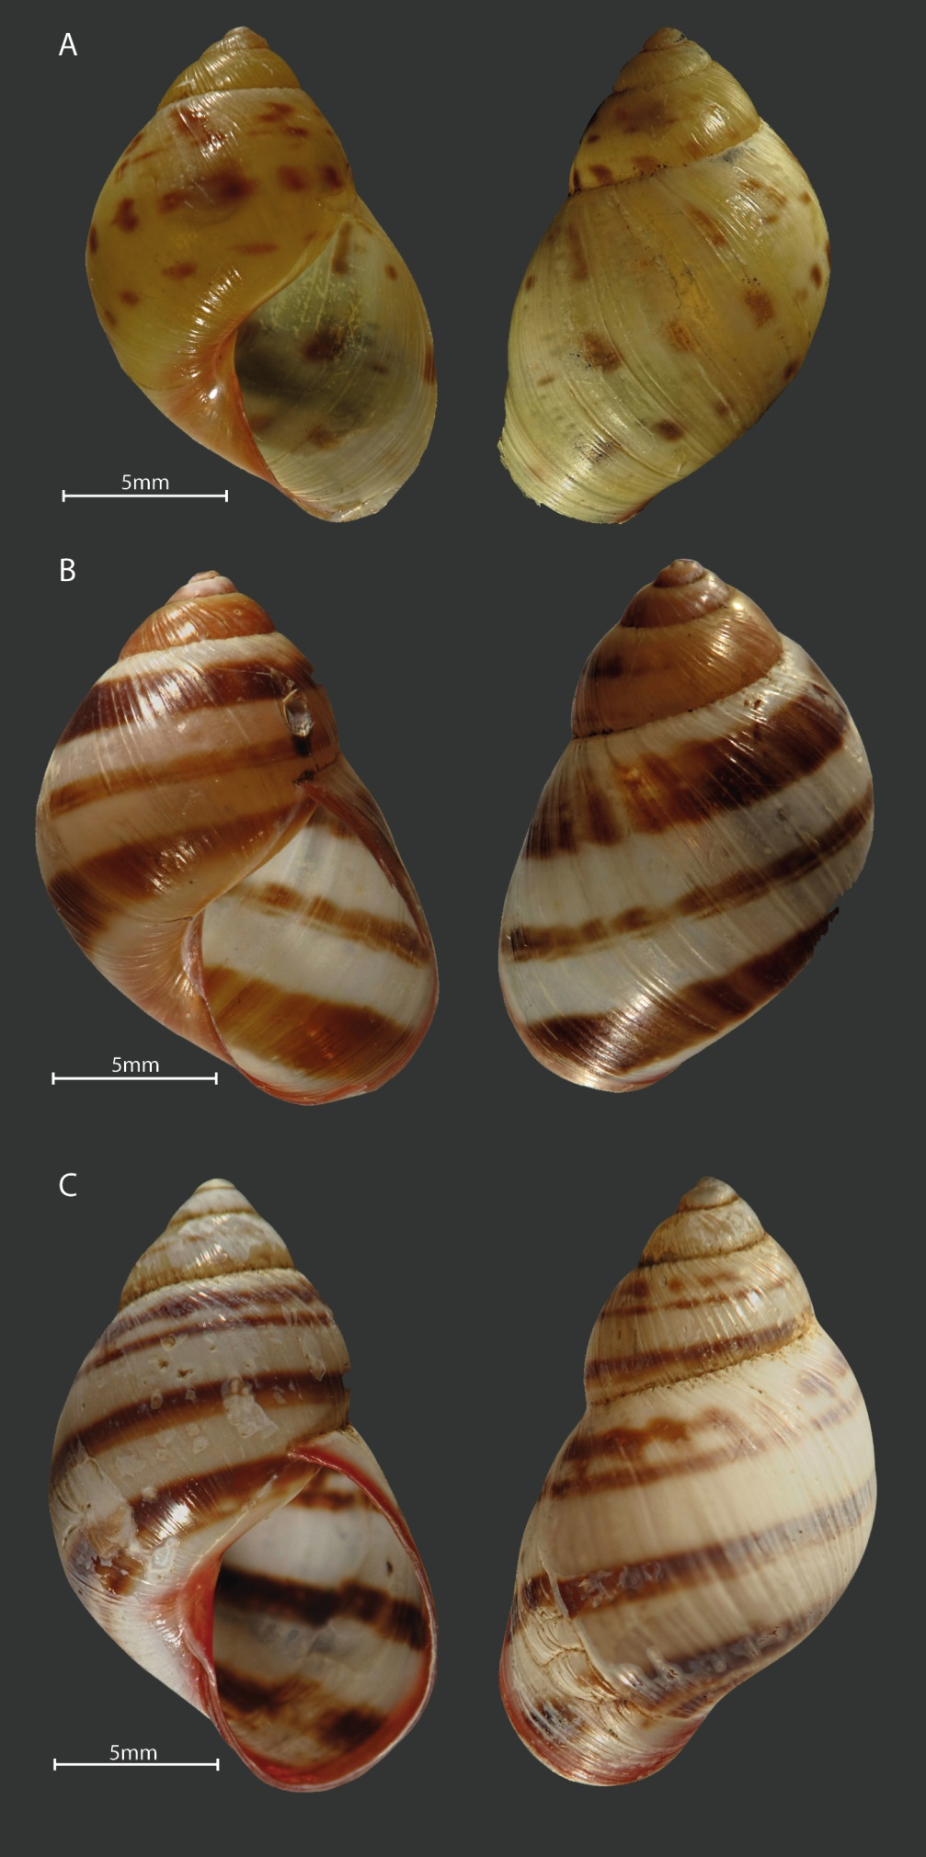
Figure 1. Shell color pattern of Drymaeus tripictus. A and B have some white or translucids dots on body whorl similar to Drymaeus irazuensis. Mating was performed between the following color patterns: A with B., B. with C.

Figures
Figures must be in color. The title of the figure must be centered and have a period at the end.

Figure 1. Satisfaction of the experience survey.

Tables:
The word “TABLE” is in uppercase, and do not uses bold. The titles of the tables are brief and only the scientific names are in italics. The explanations and symbols used in the tables appear at the bottom of the tables. Bold is used for clarification only. Tables do not use bold or uppercase. Numbering use spaces to separate thousands and millions, and commas to separate decimals. The title of the table should not have a period at the end.

