For a better result, please use of this template using the functions "Copy" and "Paste plain text" in each section.

LITERATURE REVIEW

Title of the article (Calibri 14pt, centered, bold, except scientific names. For studies on plants include Family, for studies on animals (Order: Family). Must be concise, easy to understand, and strictly related to what is presented in the article (15 words maximum).

Author complete name¹, Author complete name², Author complete name³ & Author complete name⁴

Calibri 10pt, left aligned, bold. The name of the authors is written in full, last name after the name or middle name.

Affiliations (Calibri 9pt)
Addresses are numbered, finishing with a “;” followed by the email address (do not include the word "email") and the ORCID identification number, separated by a comma. When two or more authors share the same affiliation, separate the next email address with a comma.
Example:
1. Instituto Nacional de Salud, Grupo de Microscopía y Análisis de Imágenes, Av. Calle 26 Nº 51-60 Bogotá, Colombia; lsarmiento@ins.gov.co, https://orcid.org/0000-0002-4018-775X
2. Universidad Estatal a Distancia, Vicerrectoría de Investigación, Laboratorio de Ecología Urbana, 2050 Sabanilla, San José, Costa Rica; cseas@uned.ac.cr, https://orcid.org/0000-0002-4018-775X
3. University of Georgia, Costa Rica Campus. Apartado 108-5655, Monteverde, Costa Rica; fabricio@uga.edu, https://orcid.org/0000-0002-4018-775X
4. Council on International Educational Exchange, Sustainability Center Monteverde, Costa Rica; kmasters@ciee.org, https://orcid.org/0000-0002-4018-775X

Please do not write here Received XX-XX-XXXX Corrected XX-XX-XXXX Accepted XX-XX-XXXX
DOI:
IMPORTANT NOTE (PLEASE DELETE THIS NOTE ONCE YOU INSERT YOUR MANUSCRIPT TEXT): The narrative style required by the journal is first-person, active voice. This applies to the entire text, including the abstracts. (For example, "we collected 80 samples" instead of the old style "80 samples were collected"). If you wish to update yourself in this area, we suggest reading: https://www.nature.com/nature-portfolio/for-authors/write.

ABSTRACT. Calibri, 9pt, justified. The text will include the main objectives of the research, scope, methodology employed, main results and conclusions. The abstract must be clear, coherent and concise, for which it is suggested to review and verify data, syntax, spelling, do not include equations, figures, tables, or bibliographic references. It must accurately reflect the content of the article. It must be written in first person. It should be only one paragraph of 200-300 words.
Example:
ABSTRACT. Introduction: Tropical dry forests are even more endangered than tropical rain forests. Objective: To critically review the literature on how tropical dry forests will be affected by climate change. Methods: We analyze all the literature retrieved in Google Scholar by the search words tropical dry forest climate change, up to January 2021. Results: Most publications predict that climate change will affect rainfall regimes, negatively impacting the internal dynamics of dry forests and even shifting their geographical borders at longer timescales. Conclusion: Climate change will impact the many valuable ecosystem services of tropical dry forests and societies must prepare for that change.
Keywords: Calibri, 9pt, left aligned, lowercase and separated by commas, must include 5-7 words that describe the topic and that are not in the title, nor in the abstract.

RESUMEN. Include the title of the article in Spanish in between quotation marks “”. Follow the same structure, format and length as the abstract. It helps to identify the main topics or aspects of the article and is important for indexing in bibliographic databases.
Ejemplo:
RESUMEN. “El impacto del cambio climático sobre los bosques secos tropicales: una revisión crítica”. Introducción: Los bosques secos tropicales están aún más amenazados que los bosques lluviosos tropicales. Objetivo: Revisar críticamente la literatura sobre cómo los bosques secos tropicales se verán afectados por el cambio climático. Métodos: Analizamos toda la literatura recuperada en Google Scholar mediante las palabras de búsqueda cambio climático de bosque seco tropical, hasta enero de 2021. Resultados: La mayoría de las publicaciones predicen que el cambio climático afectará los regímenes de lluvia, impactando negativamente la dinámica interna de los bosques secos e incluso cambiando sus fronteras geográficas en escalas de tiempo más largas. Conclusión: El cambio climático afectará a los valiosos servicios ecosistémicos de los bosques secos tropicales y las sociedades deben prepararse para ese cambio.
Palabras clave: Calibri, 9pt, left aligned, lowercase and separated by commas, must include 5-7 words in Spanish that describe the topic and that are not in the title, nor in the abstract.

The content of a literature review uses Calibri, 11, justified, each paragraph indented in the first line. Use a maximum of 12 000 words.
Title your sections INTRODUCTION (which closes with the objective), MATERIALS AND METHODS, RESULTS and DISCUSSION. These subtitles are written in uppercase, bold and do not end with any punctuation. Do not include a Conclusions section, these are written very briefly as the final paragraph of the discussion. Remember to follow the citation guidelines of APA 7 within the text and in the REFERENCES section.
Make a clear statement of the problem, based on the relevant literature; specify which databases were used to find the literature, search keywords, the number of documents found, and the criteria used to decide which ones would be analyzed. Organize the results logically, with appropriate subtitles. In the discussion, compare your results with those already published in the literature (if your results are unexpected, analyze possible causes), and close with a concluding paragraph. You can include figures and color images to illustrate your study.

MATERIALS AND METHODS

Calibri 11pt, justified, each paragraph indented on the first line.
This section should be thoroughly enough and provide details to allow the work to be repeated by others. Specify which databases were used to find the literature, search keywords, the number of documents found, and the criteria used to decide which ones would be analyzed.
The subtitles of the sections are written in bold, followed by a colon, and then a space. The text begins with a capital letter. Figures or maps must be in color and cited within the text.
The best literature reviews are those that start from a concrete hypothesis and analyze them based on the meta-analysis of the literature.

RESULTS

Calibri 11pt, justified, each paragraph indented on the first line.
The results should be presented in a logical sequence within the text, including tables and figures. Avoid presenting repeated data in different formats. Figures or maps must be in color.

DISCUSSION

Calibri 11pt, justified, each paragraph indented on the first line.
The discussion should analyze the results in relation to the hypotheses formulated in the introduction and the location of the study in the context of other publications or research. Pay special attention to discussing possible methodological or interpretive weaknesses in previous studies, and the existing gaps in the knowledge of the subject. Provide clear and concrete recommendations for future studies that could fill those gaps.

ACKNOWLEDGMENTS

In this part of the article the author acknowledges the people or institutions that helped him or her during the research. Scholarships and institutions that finance the research are cited.
Open this section as follows: We thank... followed by the shortest possible list of people and institutions.

ETHICS, CONFLICTS , FUNDING STATEMENT AND AI USE

Calibri 11pt, justificado, cada párrafo con sangría en la primera línea.
This is an example, please use your initials and contributions, and adjust this paragraph to the characteristics of your work: The author(s) declares that he/she/they have fully complied with all pertinent ethical and legal requirements, both during the study and in the production of the manuscript; that there are no conflicts of interest of any kind; that all financial sources are fully and clearly stated in the acknowledgements section; and that they fully agree with the final edited version of the article. A signed document has been filed in the journal archives. In the preparation of this work, the Artificial Intelligence (AI) tool [name and version] was used on [date or period] solely for [task or tasks, e.g., translation, exploratory analysis, figure generation, or reference verification]. The author(s) reviewed and validated the content and assume full responsibility for the final result. Only temporary chats were used when uploading unpublished third-party material to external tools. No substantive part of the analysis, interpretation, or conclusions was delegated to AI.
The statement of each author’s contribution to the manuscript is as follows: J.G.A.R. and M.C.C.: Study design, data collection and analysis. V.P.M.: Data collection. All co-authors: preparation and final approval of the manuscript.

REFERENCES

Font Calibri, size 9pt, with a single line spacing between each reference and a hanging indent. Place the references in alphabetical order and APA 7 Style.

EXAMPLES

Journal Article
Author, A., Author, B. & Author, C. (2019). Title of Article. Periodical Title, Volume(Issue), page range. https://doi.org/xx.xxxxxxxxxx.

Note: In Periodical Title and Volume use italic type.

Horn, S. P., Johanson, E. N., Haberyan, K. A., Boehm, M. S., Johanson, J. L., Sánchez P., M., & Hernández V., M. (2018). Initial limnological observations at five small lakes in southern Pacific Costa Rica. UNED Research Journal, 10(1), 119-134. https://doi.org/10.22458/urj.v10i1.2015

Book
Author(s) Last name, Name initials. (Year). Title of book. Publication City: Publisher.

Sapolsky, R. M. (2017). Behave: The biology of humans at our best and worst. Penguin Books.

Chapter in an edited book
Author, A. (Year). Title of Chapter. In E.E. Editor (Ed.), Title of Book (xx ed., Vol. xx, pp. xxx–xxx). Publisher.

Dillard, J. P. (2020). Currents in the study of persuasion. In M.B. Oliver, A.A. Raney, & J. Bryant (Eds.), Media effects: Advances in theory and research (4th ed., pp. 115-129). Routledge.

Dissertation or Thesis References
Author, A. (Year). Title of Dissertation [Doctoral dissertation, Name of Institution Awarding the Degree]. Database Name.

Zambrano-Vázquez, L. (2016). The interaction of state and trait worry on response monitoring in those with worry and obsessive-compulsive symptoms [Doctoral dissertation, University of Arizona]. UA Campus Repository. https://repository.arizona.edu/handle/10150/620615

Webpage on a website
Author, A., Author, B., & Author, C. (Date). Title of the Website. Webpage name. https://url.com

Center for Systems Science and Engineering. (2020). COVID-19 Dashboard by the Center for Systems Science and Engineering (CSSE) at Johns Hopkins University. Johns Hopkins University. https://gisanddata.maps.arcgis.com/apps/opsdashboard/index.html#/bda7594740fd40299423467b48e9ecf6

More information:
https://www.apastyle.org/
https://libguides.csudh.edu/citation/apa-7

aDDITIONAL FORMATTING INFORMATION

Figures and tables should be located within the text, not at the end. This is just a guide

Photographs:
Photographs can be inserted at the end of the word document or if the files are very large, these can be sent in separate files; in both cases they must be in JPG, ai, psd or TIFF format, at a minimum resolution of 300 dpi (high resolution, you can confirm this by enlarging the image to full screen and should look sharp, not pixelated). Figures will be reduced to a width of 6-12 cm so please ensure the labels will be easy to read, even after this reduction.
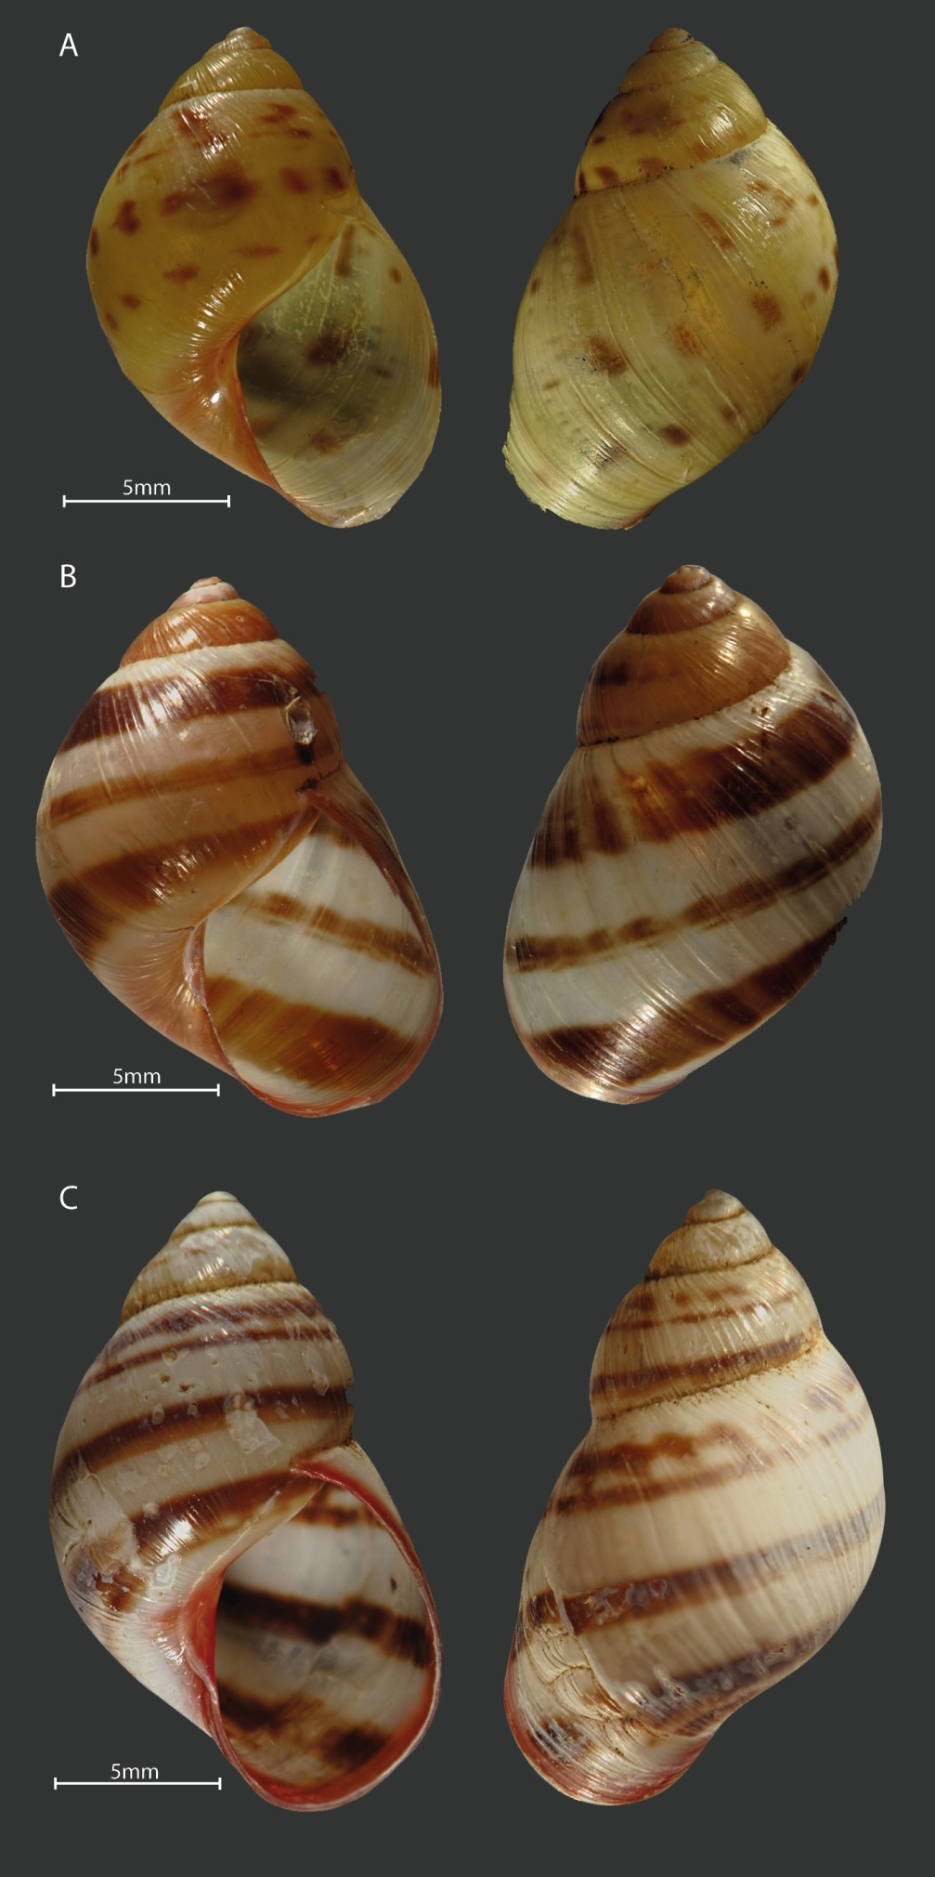
Figure 1. Shell color pattern of Drymaeus tripictus. A and B have some white or translucids dots on body whorl similar to Drymaeus irazuensis. Mating was performed between the following color patterns: A with B., B. with C.

Figures
Figures must be in color. The title of the figure must be centered and have a period at the end.

Figure 1. Satisfaction of the experience survey.

Tables:
The word “TABLE” is in uppercase, and do not uses bold. The titles of the tables are brief and only the scientific names are in italics. The explanations and symbols used in the tables appear at the bottom of the tables. Bold is used for clarification only. Tables do not use bold or uppercase. Numbering use spaces to separate thousands and millions, and commas to separate decimals. The title of the table should not have a period at the end.

