For a better result, please use of this template using the functions "Copy" and "Paste plain text" in each section.
RANGE EXTENSION

Title of the article (Calibri 14pt, centered, bold, except scientific names. For studies on plants include Family, for studies on animals (Order: Family). Must be concise, easy to understand, and strictly related to what is presented in the article (15 words maximum).

Author complete name¹, Author complete name², Author complete name³ & Author complete name⁴

Calibri 10pt, left aligned, bold. The name of the authors is written in full, last name after the name or middle name.

Affiliations (Calibri 9pt)
Addresses are numbered, finishing with a “;” followed by the email address (do not include the word "email") and the ORCID identification number, separated by a comma. When two or more authors share the same affiliation, separate the next email address with a comma.
Example:
1. Instituto Nacional de Salud, Grupo de Microscopía y Análisis de Imágenes, Av. Calle 26 Nº 51-60 Bogotá, Colombia; lsarmiento@ins.gov.co, https://orcid.org/0000-0002-4018-775X
2. Universidad Estatal a Distancia, Vicerrectoría de Investigación, Laboratorio de Ecología Urbana, 2050 Sabanilla, San José, Costa Rica; cseas@uned.ac.cr, https://orcid.org/0000-0002-4018-775X
3. University of Georgia, Costa Rica Campus. Apartado 108-5655, Monteverde, Costa Rica; fabricio@uga.edu, https://orcid.org/0000-0002-4018-775X
4. Council on International Educational Exchange, Sustainability Center Monteverde, Costa Rica; kmasters@ciee.org, https://orcid.org/0000-0002-4018-775X

Please do not write here Received XX-XX-XXXX Corrected XX-XX-XXXX Accepted XX-XX-XXXX
DOI:

ABSTRACT. Calibri, 9pt, justified. The text will include the main objectives of the research, scope, methodology employed, main results and conclusions. The abstract must be clear, coherent and concise, for which it is suggested to review and verify data, syntax, spelling, do not include equations, figures, tables, or bibliographic references. It must accurately reflect the content of the article. It must be written in first person. It should be only one paragraph of 60-80 words  Example:  ABSTRACT. Introduction: In Honduras there are five bat species in the genus Lasiurus. Objective: To extend the geographic range of Lasiurus ega. Methods: Throughout December 2020 we collected bats with 5 mist nets in Laguna El Cacao, Jutiapa. Results: We identified a specimen as L. ega, based on color, teeth, total size and size of the forearm. Conclusion: we extend the distribution of this bat to the north coast of Honduras.  Keywords: Calibri, 9pt, left aligned, lowercase and separated by commas, must include 5-7 words that describe the topic and that are not in the title, nor in the abstract. | RESUMEN. Include the title of the article in Spanish in between quotation marks “”. Follow the same structure, format and length as the abstract. It helps to identify the main topics or aspects of the article and is important for indexing in bibliographic databases.  Ejemplo:  RESUMEN. “Ampliación de ámbito del murciélago Lasiurus ega (Chiroptera: Vespertilionidae) en Honduras”. Introducción: En Honduras hay cinco especies de murciélago del género Lasiurus. Objetivo: extender el rango geográfico de Lasiurus ega. Métodos: Durante todo diciembre de 2020 recolectamos murciélagos con 5 redes de niebla en Laguna El Cacao, Jutiapa. Resultados: Identificamos un ejemplar como L. ega, con base en color, dientes, tamaño total y tamaño del antebrazo. Conclusión: ampliamos la distribución de este murciélago a la costa norte de Honduras.  Palabras clave: Calibri, 9pt, left aligned, lowercase and separated by commas, must include 5-7 words in Spanish that describe the topic and that are not in the title, nor in the abstract.

The text of a Distribution range publication uses Calibri, 11, justified, each paragraph indented in the first line. Use a maximum of 2000 words.
Follow the normal sequence of introduction, objective, methods, results and discussion, but do not use those subtitles. Include the details of the herbarium or museum where the witness specimens of your study are deposited. If this is not possible, back up your record with photos, videos, or audio recordings.
Make a clear but brief statement of the problem, based on the relevant literature; Specifically indicate the current distribution, the new sites reported and a detailed description of the observation, as well as the duration of the study; sample size; methods and results. Compare your results with published literature (if your results are unexpected, analyze possible causes), and close with a concluding paragraph.
Remember to follow the citation guidelines of APA 7 within the text and in the REFERENCES section.

ACKNOWLEDGMENTS

In this part of the article the author acknowledges the people or institutions that helped him or her during the research. Scholarships and institutions that finance the research are cited.
Open this section as follows: We thank... followed by the shortest possible list of people and institutions.

ETHICS, CONFLICT OF INTEREST, AND FUNDING STATEMENT

Calibri 11pt, justificado, cada párrafo con sangría en la primera línea.
This is an example, please use your initials and contributions, and adjust this paragraph to the characteristics of your work: The author(s) declares that he/she/they have fully complied with all pertinent ethical and legal requirements, both during the study and in the production of the manuscript; that there are no conflicts of interest of any kind; that all financial sources are fully and clearly stated in the acknowledgements section; and that they fully agree with the final edited version of the article. A signed document has been filed in the journal archives.
The statement of each author’s contribution to the manuscript is as follows: J.G.A.R. and M.C.C.: Study design, data collection and analysis. V.P.M.: Data collection. All co-authors: preparation and final approval of the manuscript.

REFERENCES

Font Calibri, size 9pt, with a single line spacing between each reference and a hanging indent. Place the references in alphabetical order and APA 7 Style.

EXAMPLES

Journal Article
Author, A., Author, B. & Author, C. (2019). Title of Article. Periodical Title, Volume(Issue), page range. https://doi.org/xx.xxxxxxxxxx.

Note: In Periodical Title and Volume use italic type.

Horn, S. P., Johanson, E. N., Haberyan, K. A., Boehm, M. S., Johanson, J. L., Sánchez P., M., & Hernández V., M. (2018). Initial limnological observations at five small lakes in southern Pacific Costa Rica. UNED Research Journal, 10(1), 119-134. https://doi.org/10.22458/urj.v10i1.2015

Book
Author(s) Last name, Name initials. (Year). Title of book. Publication City: Publisher.

Sapolsky, R. M. (2017). Behave: The biology of humans at our best and worst. Penguin Books.

Chapter in an edited book
Author, A. (Year). Title of Chapter. In E.E. Editor (Ed.), Title of Book (xx ed., Vol. xx, pp. xxx–xxx). Publisher.

Dillard, J. P. (2020). Currents in the study of persuasion. In M.B. Oliver, A.A. Raney, & J. Bryant (Eds.), Media effects: Advances in theory and research (4th ed., pp. 115-129). Routledge.

Dissertation or Thesis References
Author, A. (Year). Title of Dissertation [Doctoral dissertation, Name of Institution Awarding the Degree]. Database Name.

Zambrano-Vázquez, L. (2016). The interaction of state and trait worry on response monitoring in those with worry and obsessive-compulsive symptoms [Doctoral dissertation, University of Arizona]. UA Campus Repository. https://repository.arizona.edu/handle/10150/620615

Webpage on a website
Author, A., Author, B., & Author, C. (Date). Title of the Website. Webpage name. https://url.com

Center for Systems Science and Engineering. (2020). COVID-19 Dashboard by the Center for Systems Science and Engineering (CSSE) at Johns Hopkins University. Johns Hopkins University. https://gisanddata.maps.arcgis.com/apps/opsdashboard/index.html#/bda7594740fd40299423467b48e9ecf6

More information:
https://www.apastyle.org/
https://libguides.csudh.edu/citation/apa-7

aDDITIONAL FORMATTING INFORMATION

Figures and tables should be located within the text, not at the end. This is just a guide

Photographs:
Photographs can be inserted at the end of the word document or if the files are very large, these can be sent in separate files; in both cases they must be in JPG, ai, psd or TIFF format, at a minimum resolution of 300 dpi (high resolution, you can confirm this by enlarging the image to full screen and should look sharp, not pixelated). Figures will be reduced to a width of 6-12 cm so please ensure the labels will be easy to read, even after this reduction.
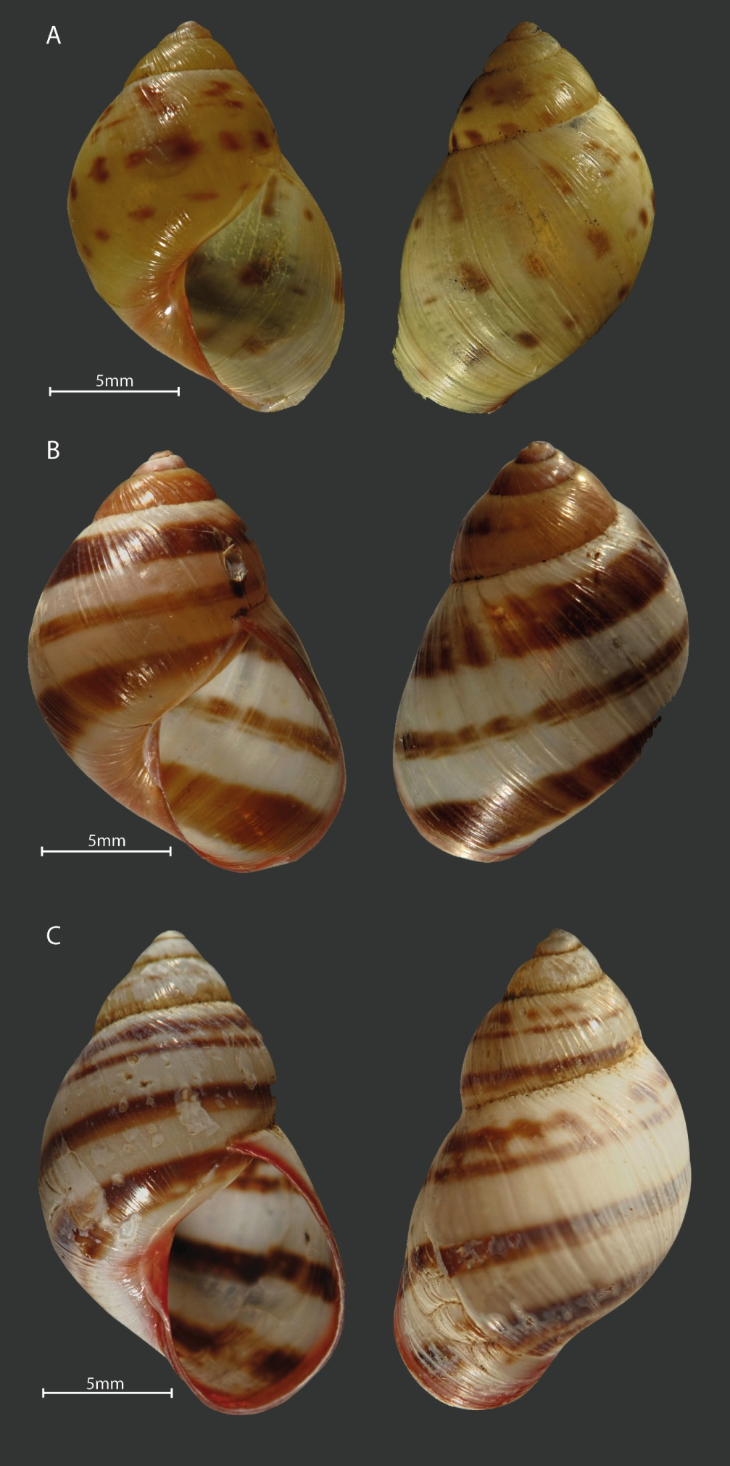
Figure 1. Shell color pattern of Drymaeus tripictus. A and B have some white or translucids dots on body whorl similar to Drymaeus irazuensis. Mating was performed between the following color patterns: A with B., B. with C.

Figures
Figures must be in color. The title of the figure must be centered and have a period at the end.

Figure 1. Satisfaction of the experience survey.

Tables:
The word “TABLE” is in uppercase, and do not uses bold. The titles of the tables are brief and only the scientific names are in italics. The explanations and symbols used in the tables appear at the bottom of the tables. Bold is used for clarification only. Tables do not use bold or uppercase. Numbering use spaces to separate thousands and millions, and commas to separate decimals. The title of the table should not have a period at the end.

