For a better result, please use of this template using the functions "Copy" and "Paste plain text" in each section.
NOTE

Title of the article (Calibri 14pt, centered, bold, except scientific names. For studies on plants include Family, for studies on animals (Order: Family). Must be concise, easy to understand, and strictly related to what is presented in the article (15 words maximum).

Author complete name¹, Author complete name², Author complete name³ & Author complete name⁴

Calibri 10pt, left aligned, bold. The name of the authors is written in full, last name after the name or middle name.

Affiliations (Calibri 9pt)
Addresses are numbered, finishing with a “;” followed by the email address (do not include the word "email") and the ORCID identification number, separated by a comma. When two or more authors share the same affiliation, separate the next email address with a comma.
Example:
1. Instituto Nacional de Salud, Grupo de Microscopía y Análisis de Imágenes, Av. Calle 26 Nº 51-60 Bogotá, Colombia; lsarmiento@ins.gov.co, https://orcid.org/0000-0002-4018-775X
2. Universidad Estatal a Distancia, Vicerrectoría de Investigación, Laboratorio de Ecología Urbana, 2050 Sabanilla, San José, Costa Rica; cseas@uned.ac.cr, https://orcid.org/0000-0002-4018-775X
3. University of Georgia, Costa Rica Campus. Apartado 108-5655, Monteverde, Costa Rica; fabricio@uga.edu, https://orcid.org/0000-0002-4018-775X
4. Council on International Educational Exchange, Sustainability Center Monteverde, Costa Rica; kmasters@ciee.org, https://orcid.org/0000-0002-4018-775X

Please do not write here Received XX-XX-XXXX Corrected XX-XX-XXXX Accepted XX-XX-XXXX
DOI:

IMPORTANT NOTE (PLEASE DELETE THIS NOTE ONCE YOU INSERT YOUR MANUSCRIPT TEXT): The narrative style required by the journal is first-person, active voice. This applies to the entire text, including the abstracts. (For example, "we collected 80 samples" instead of the old style "80 samples were collected"). If you wish to update yourself in this area, we suggest reading: https://www.nature.com/nature-portfolio/for-authors/write.

ABSTRACT. Calibri, 9pt, justified. The text will include the main objectives of the research, scope, methodology employed, main results and conclusions. The abstract must be clear, coherent and concise, for which it is suggested to review and verify data, syntax, spelling, do not include equations, figures, tables, or bibliographic references. It must accurately reflect the content of the article. It must be written in first person. It should be only one paragraph of 80-150 words.
Example:
ABSTRACT. Introduction: Semi-aquatic turtles often dive to escape from terrestrial predators, but there are almost no records of diving duration. Objective: To measure diving time in semi-aquatic turtles. Methods: We tested diving duration in Kinosternon scorpioides, K. leucostomum; Rhinoclemmys pulcherrima and R. funerea. Results: Diving times ranged from 1,4 minutes in K. leucostomum to one hour in K. scorpioides. Conclusion: these turtles can hide under water for up to one hour, but time varies greatly between species and individuals.
Keywords: Calibri, 9pt, left aligned, lowercase and separated by commas, must include 5-7 words that describe the topic and that are not in the title, nor in the abstract.

RESUMEN. Include the title of the article in Spanish in between quotation marks “”. Follow the same structure, format and length as the abstract. It helps to identify the main topics or aspects of the article and is important for indexing in bibliographic databases.
Ejemplo:
RESUMEN. “Períodos de inmersión en cuatro tortugas neotropicales”. Introducción: Las tortugas semiacuáticas suelen bucear para escapar de los depredadores terrestres, pero casi no hay registros de la duración del buceo. Objetivo: Medir el tiempo de buceo en tortugas semiacuáticas. Métodos: Probamos la duración del buceo en Kinosternon scorpioides, K. leucostomum; Rhinoclemmys pulcherrima y R. funerea. Resultados: Los tiempos de inmersión variaron de 1,4 minutos en K. leucostomum a una hora en K. scorpioides. Conclusión: estas tortugas pueden esconderse bajo el agua hasta por una hora, pero el tiempo varía mucho entre especies e individuos.
Palabras clave: Calibri, 9pt, left aligned, lowercase and separated by commas, must include 5-7 words in Spanish that describe the topic and that are not in the title, nor in the abstract.

The text of uses Calibri, 11, justified, each paragraph indented in the first line. Use a maximum of 1000 words.
The purpose of a note is to briefly communicate a finding that cannot be published as part of a larger study, due to a justified reason.
Follow the normal sequence of introduction, objective, methods, results and discussion, but do not use those subtitles. Make a clear statement of the problem, based on the relevant literature; specifically indicate the place; duration of study; sample size; hypotheses to be evaluated, methods and results. In the discussion, compare your results with those already published in the literature (if your results are unexpected, analyze possible causes), and close with a concluding paragraph. Also, you can attach color images that illustrate your study.
Remember to follow the citation guidelines of APA 7 within the text and in the REFERENCES section.

ACKNOWLEDGMENTS

In this part of the article the author acknowledges the people or institutions that helped him or her during the research. Scholarships and institutions that finance the research are cited.
Open this section as follows: We thank... followed by the shortest possible list of people and institutions.

ETHICS, CONFLICTS , FUNDING STATEMENT AND AI USE

Calibri 11pt, justificado, cada párrafo con sangría en la primera línea.
This is an example, please use your initials and contributions, and adjust this paragraph to the characteristics of your work: The author(s) declares that he/she/they have fully complied with all pertinent ethical and legal requirements, both during the study and in the production of the manuscript; that there are no conflicts of interest of any kind; that all financial sources are fully and clearly stated in the acknowledgements section; and that they fully agree with the final edited version of the article. A signed document has been filed in the journal archives.
In the preparation of this work, the Artificial Intelligence (AI) tool [name and version] was used on [date or period] solely for [task or tasks, e.g., translation, exploratory analysis, figure generation, or reference verification]. The author(s) reviewed and validated the content and assume full responsibility for the final result. Only temporary chats were used when uploading unpublished third-party material to external tools. No substantive part of the analysis, interpretation, or conclusions was delegated to AI
The statement of each author’s contribution to the manuscript is as follows: J.G.A.R. and M.C.C.: Study design, data collection and analysis. V.P.M.: Data collection. All co-authors: preparation and final approval of the manuscript.

REFERENCES

Font Calibri, size 9pt, with a single line spacing between each reference and a hanging indent. Place the references in alphabetical order and APA 7 Style.

EXAMPLES

Journal Article
Author, A., Author, B. & Author, C. (2019). Title of Article. Periodical Title, Volume(Issue), page range. https://doi.org/xx.xxxxxxxxxx.

Note: In Periodical Title and Volume use italic type.

Horn, S. P., Johanson, E. N., Haberyan, K. A., Boehm, M. S., Johanson, J. L., Sánchez P., M., & Hernández V., M. (2018). Initial limnological observations at five small lakes in southern Pacific Costa Rica. UNED Research Journal, 10(1), 119-134. https://doi.org/10.22458/urj.v10i1.2015

Book
Author(s) Last name, Name initials. (Year). Title of book. Publication City: Publisher.

Sapolsky, R. M. (2017). Behave: The biology of humans at our best and worst. Penguin Books.

Chapter in an edited book
Author, A. (Year). Title of Chapter. In E.E. Editor (Ed.), Title of Book (xx ed., Vol. xx, pp. xxx–xxx). Publisher.

Dillard, J. P. (2020). Currents in the study of persuasion. In M.B. Oliver, A.A. Raney, & J. Bryant (Eds.), Media effects: Advances in theory and research (4th ed., pp. 115-129). Routledge.

Dissertation or Thesis References
Author, A. (Year). Title of Dissertation [Doctoral dissertation, Name of Institution Awarding the Degree]. Database Name.

Zambrano-Vázquez, L. (2016). The interaction of state and trait worry on response monitoring in those with worry and obsessive-compulsive symptoms [Doctoral dissertation, University of Arizona]. UA Campus Repository. https://repository.arizona.edu/handle/10150/620615

Webpage on a website
Author, A., Author, B., & Author, C. (Date). Title of the Website. Webpage name. https://url.com

Center for Systems Science and Engineering. (2020). COVID-19 Dashboard by the Center for Systems Science and Engineering (CSSE) at Johns Hopkins University. Johns Hopkins University. https://gisanddata.maps.arcgis.com/apps/opsdashboard/index.html#/bda7594740fd40299423467b48e9ecf6

More information:
https://www.apastyle.org/
https://libguides.csudh.edu/citation/apa-7

aDDITIONAL FORMATTING INFORMATION

Figures and tables should be located within the text, not at the end. This is just a guide

Photographs:
Photographs can be inserted at the end of the word document or if the files are very large, these can be sent in separate files; in both cases they must be in JPG, ai, psd or TIFF format, at a minimum resolution of 300 dpi (high resolution, you can confirm this by enlarging the image to full screen and should look sharp, not pixelated). Figures will be reduced to a width of 6-12 cm so please ensure the labels will be easy to read, even after this reduction.
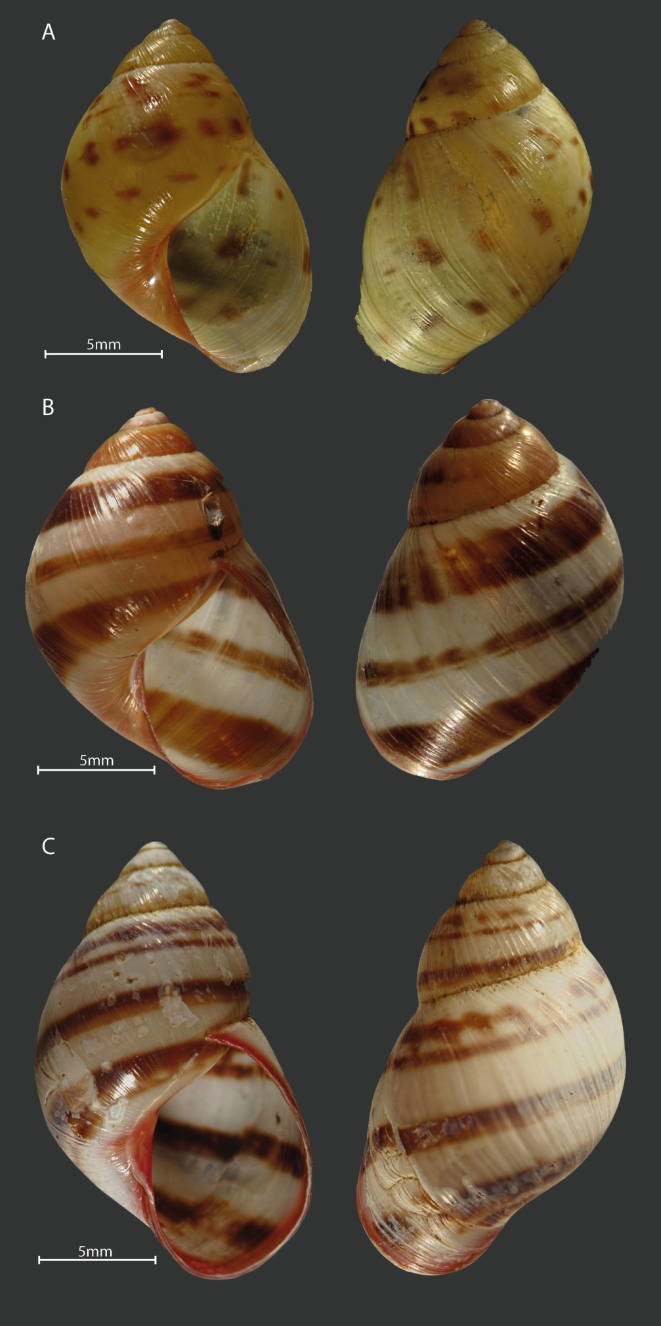
Figure 1. Shell color pattern of Drymaeus tripictus. A and B have some white or translucids dots on body whorl similar to Drymaeus irazuensis. Mating was performed between the following color patterns: A with B., B. with C.

Figures
Figures must be in color. The title of the figure must be centered and have a period at the end.

Figure 1. Satisfaction of the experience survey.

Tables:
The word “TABLE” is in uppercase, and do not uses bold. The titles of the tables are brief and only the scientific names are in italics. The explanations and symbols used in the tables appear at the bottom of the tables. Bold is used for clarification only. Tables do not use bold or uppercase. Numbering use spaces to separate thousands and millions, and commas to separate decimals. The title of the table should not have a period at the end.

